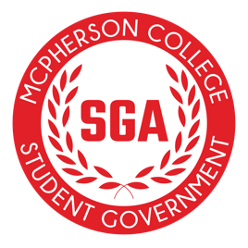
Meeting Minutes
Sunday, August 24, 2025
6:00pm | Campus Commons Boardroom

- Call to Order
- Attendance - Track
- Approval of Minutes
- Meeting with Amy Beckman
- Mission Statement & Core Values
- Discuss mission statement and core values for SGA
- Meeting with Billy
- Share Homecoming event meeting notes
- Discuss clubs and orgs. expectations for homecoming
- Noah Landever: Budget Conversation
- Receipt training
- V.P. Aaron Meis
  - Focus groups
    - Goal of doing one-on-ones with students
- Office Hours
  - Leadership role
- Calendar
  - New release
- New Business
- Freshman Senator Applications
- Discussion/Announcements/Questions
- Adjournment
- Next Meeting Date:
    - Next Sunday: August 31, 2025

